SOCIETY OF DISTRICT COUNCIL TREASURERS
President: Norma Atlay, CPFA

Date: 23 September 2016

Dear Sir/Madam,

DCLG Consultation: Fair Funding Review

This letter is in response to the consultation document published by the DCLG on 5th July in respect of the Fair funding review. The Society of District Council Treasurers welcomes the opportunity to respond. By way of background, the Society currently has a membership of 163 Chief Financial Officers from the 201 district councils nationally. The response to this consultation is representative of the membership of the Society and as such reflects the potential for differing views dependent on individual circumstances.
The Society welcomes the manner in which the Department for Communities and Local Government (DCLG) and the Local Government Association are working together (and with the wider local government sector) through the working groups that have been established to discuss the salient issues. Through our participation on the Steering Group and various working groups, representatives from the SDCT have consistently sought to represent the District Council case and work with colleagues to find an equitable solution.
The Society has encouraged all individual districts to respond to ensure that there is the widest possible coverage of the differing views that exist on some of the issues. We have set out our position on some of the key themes coming out of discussions and trust our comments will be considered helpful in moving forward.

Question 1: What is your view on the balance between simple and complex funding formulae?

Complexity seems to be inevitable given the importance of the system being fair. It is vital therefore that any new system is transparent.

Over the years, the current system for allocating shares of funding has become ever-more complex, to a point where it is difficult to explain how a local authority’s funding levels from the Government are determined. A mechanism that is easier to understand is an important aspiration for any new system. This will aid transparency and accountability. This does not necessarily mean that the formulae must be minimalistic.

Fairness should be a primary objective. If a distribution can be achieved through a simpler approach that would be welcome but not if this is at the expense of fairness.

The Government must examine all the evidence and listen to the views of the sector when identifying factors to take into account as part of the Fair Funding Review.

Question 2: Are there particular services for which a more detailed formula approach is needed, and – if so – what are these services?

For all services, the assessment should reflect the relative costs of providing services in different geographic areas. In particular, Shire districts face additional costs in delivering services to their more dispersed populations, and residents in these districts typically pay higher council tax but have to travel further to access services. For example:
- waste collection costs more due to the distances involved
- having a number of similar sized towns makes it extremely difficult to have any centralised provision of services, which would be possible where there was one main population centre

Question 3: Should expenditure based regression continue to be used to assess councils’ funding needs?
Question 4: What other measures besides councils’ spending on services should we consider as a measure of their need to spend?
Question 5: What other statistical techniques besides those mentioned above should be considered for arriving at the formulae for distributing funding?

Current spend is unlikely to fully reflect need as it does not take in to account the extent to which service redesign and provision has been delivered.

All approaches should be considered and assessed on their merits. There will need to be some research to assess alternative approaches and techniques (e.g. other sectors or other countries). Without details of what the alternative allocation methods might look like, it is not possible to identify which shire districts would benefit from, or be penalised by, the proposed changes implied by these questions.

The chosen basis is likely to be complex, but must also be transparent.

Question 6: What other considerations should we keep in mind when measuring the relative need of authorities?

The current Core Spending Power (CSP) assessments provide shire areas with less funding (per head) relative to metropolitan districts and London.

In 2016-17 residents of all ages in shire areas received £741.70 per head of CSP funding; which is 6% less than the national average; 5% less than metropolitan districts and 24% less than residents in London. When showing figures by dwellings; shire areas receive 7% less than the national average; 6% less than metropolitan districts and 31% less than London.

This CSP figure includes the council tax which can be shown to be unfair for shire residents. If you strip out the element of the CSP for council tax the differences become starker. Individual residents in shire areas receive, on average, 20% less than the national average; 33% less than metropolitan residents and over 46% less than residents in London. When number of dwellings replaces the resident population shire areas receive less than half that of London.

Due to the size and geography of shire districts there is also less scope to take advantage of economies of scale.

Any new system should correct this current inequality. Currently the main source of District Council Funding is the District-Level Environmental, Protective and Cultural Services (EPCS). This need block currently accounts for 92% of shire districts’ total assessed needs. We would wish to see an increase in the control total assigned to this block to take account of the additional cost pressures facing shire districts who face increasing costs for providing waste collection and recycling services and maintaining green open spaces amongst others, all services which are highly valued by the public and contributors to wider public health and well-being.

Furthermore, the redistribution mechanisms need to be future-proof given the expectation that the system would include long term fixed-period resets. This means that the Government needs to consider not only the current profile of relative needs, but also how it is likely to change in the future. The alternative would be to include sufficient regularity to reflect changes in need and in the cost of providing services, to sit alongside but separate from the reset mechanism for baseline business rates income. We note that this review is the first full reset under the current funding arrangement, and would welcome more frequent resets of the needs position, possibly as often as 5 yearly.

Question 7: What is your view on how we should take into account the growth in local taxes since 2013-14?

Local tax income should not affect the assessment of need.

As referenced in other answers there should be a consideration (across this and the Business Rates Retention consultation) of the burden of funding on local taxpayers in Shire areas.

Given that the information is available, any transitional protection should be against current funding rather than an estimate based on historic information.

The 2013/14 Formula Funding model deducts notional funding from local authorities on the basis of their notional council tax revenue. This reflects the ability to finance service expenditure locally. Of the shares allocated to the lower and upper-tiers, it is assumed that 15.1% of the tax revenue is received by the lower-tier / shire district and 84.9% is received by the upper tier / county council whereas in 2016/17, the average shire district share was only 12.9%.

County Councils now have the ability to increase their proportion of Council tax relative to a District Council through the introduction of the Adult Social Care precept. We would suggest that if DCLG were not to support the view that local tax income should not affect the assessment of need, that they review assumed tax base splits within the formula to reflect growth in the share of council tax revenue received by counties since 2013/14 relative to shire districts.

Question 8: Should we allow step-changes in local authorities’ funding following the new needs assessment?
Question 9: If not, what are your views on how we should transition to the new distribution of funding?

There should be some element of transitional protection as the impact of a single step-change might prove to be too drastic if the review results in very significant swings. To minimise the impact of transition, but keep some progression towards the needs baselines, the Government could consider using some funding from the central share to smooth the path for authorities with the sharpest reductions, with the rest of the sector seeing the changes introduced over a small number of years.

Until we have a clearer picture of the proposed mechanism changes and new responsibilities, it is not possible to be specific on timings.
The response to these questions is likely to vary from authority to authority, depending on their reliance on damping / floors, and in most cases this is ambiguous given the available information.

Question 10: What are your views on a local government finance system that assessed need and distributed funding at a larger geographical area than the current system – for example, at the Combined Authority level?
Question 11: How should we decide the composition of these areas if we were to introduce such a system?
Question 12: What other considerations would we need to keep in mind if we were to introduce such a system?

This option should be available to authorities when and if they feel it is appropriate. By mandating it, it is likely to impede collaboration where the process is at an earlier stage and where the governance structures have not yet evolved. We therefore believe that a single local authority is still the most appropriate geographic unit for assessing need and distributing funding. There should be flexibility for areas to opt in to receive funding for the whole area, in a single fund to be distributed within the area, when this is agreed by all the relevant local authorities.

A risk is that shire districts as a whole could receive less funding, if resources were diverted away from lower-tier services to higher-tier ones (e.g. for social care). For shire districts, should such a funding distribution be considered appropriate we would wish to see the risk mitigated by ring-fencing an element of the fund to support provision of district council services to prevent reallocation to other tiers of government.

Question 13: What behaviours should the reformed local government finance system incentivise?
Question 14: How can we build these incentives in to the assessment of councils’ funding needs?

The calculation of fair funding should not in itself be designed to incentivise any particular behaviour. By not basing the system on current spending, it ensures that councils that have been less efficient in the past are not inadvertently rewarded.

The retained Business Rates Retention system should already reward those areas that increase their funding from Business Rates by encouraging new businesses.

The Society trusts you will find our responses helpful and should you have any queries, please contact me.

Yours faithfully,

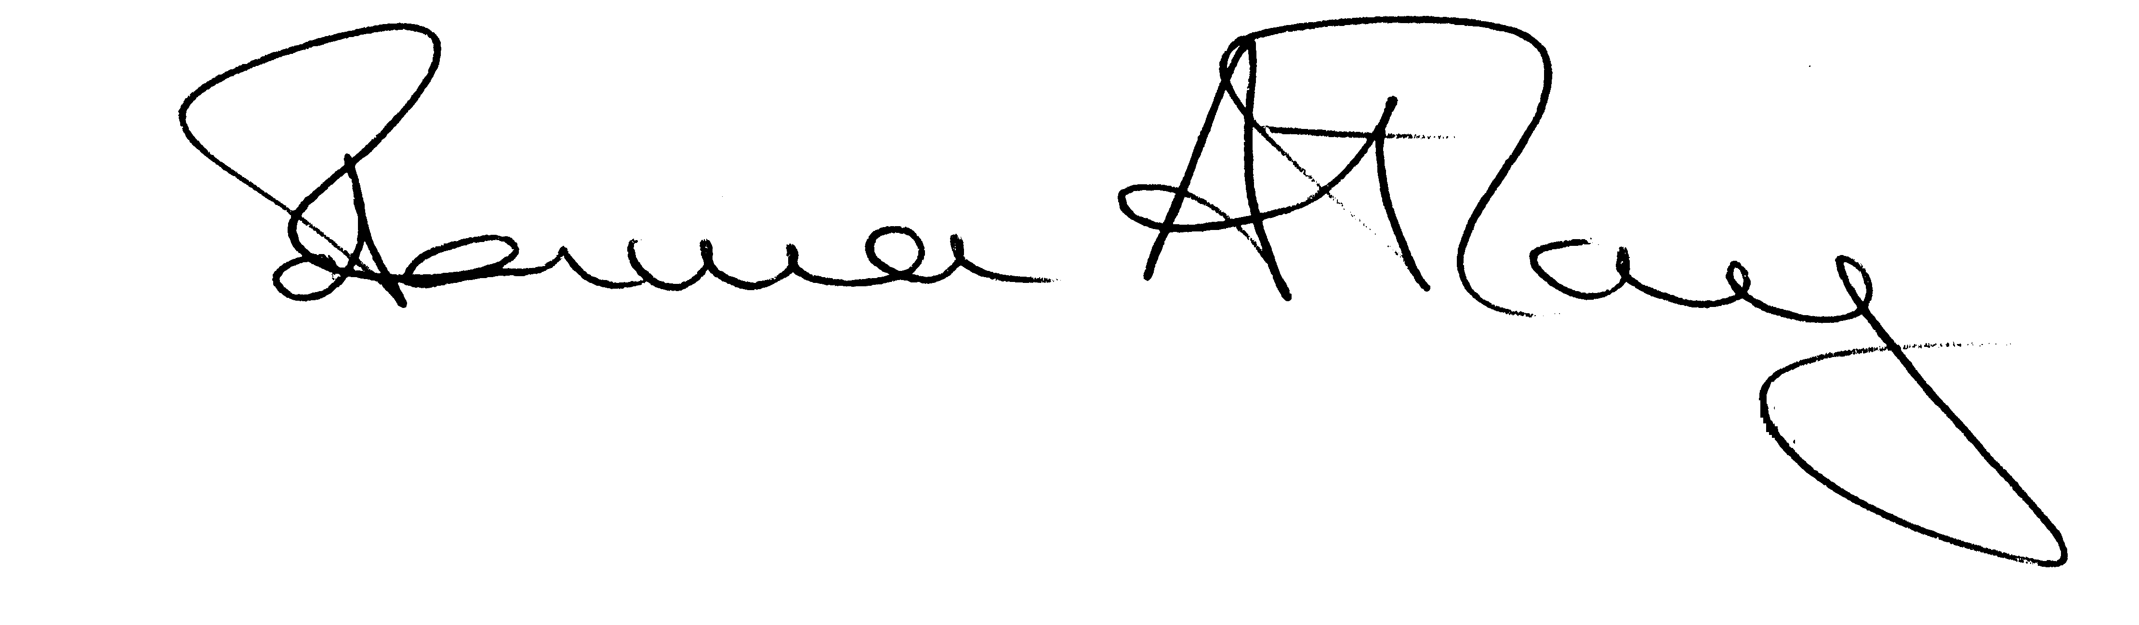

Norma Atlay
SDCT President
Norma.atlay@north-herts.gov.uk

