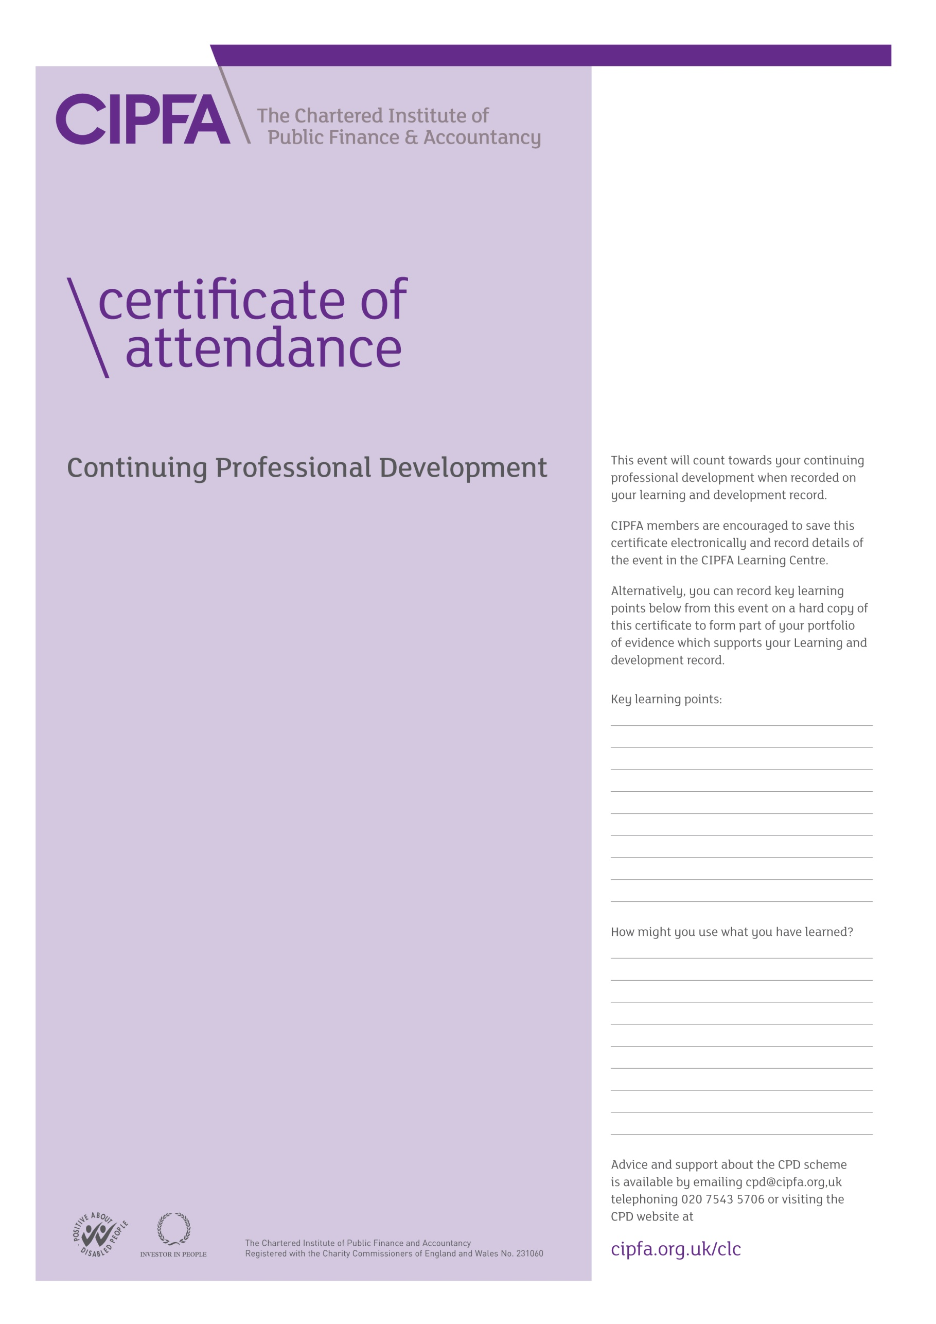

\ UPPERCASE



# CIPFA North West Society

# Annual Regional Conference 2014

# *Risk, Resilience and Innovation*

It is for the individual to determine the relevance and amount of time that this event counts towards their CPD

14 November 2014

Preston Marriott Hotel