CIPFA North West Society



**Presidents Blog – February 2016**

Well, I can’t believe where January has gone, once minute it was Christmas, next it’s almost February. It’s a sign of age I’m told……

I’ve had a great month though as I attended the Audit, Risk and Governance Group weekend event in Shrigley Hall this month. The event commenced on at teatime on the Friday with a session from John Mitchell from Wigan Council on their contracts review project followed by a session on effective service solutions from Lee Helms from PwC.

Saturday morning we were up bright and early for a session on the use of Social Media in investigations from Jon Blake of Online Operations who enlightened us to such websites as ‘pleasedontstalkme.com’ that enables you to ‘check in’ in other parts of the world in an attempt to flummox anyone who might be on your tail. A word to the wise though, it doesn’t work! Tom Powell followed that with a session on devolution assurance which was really amazing to see the journey from when AGMA started working together to now. The morning ended with an interactive session from Tim Crowley on risk appetite where we had a quiz to determine what our appetite to risk was.

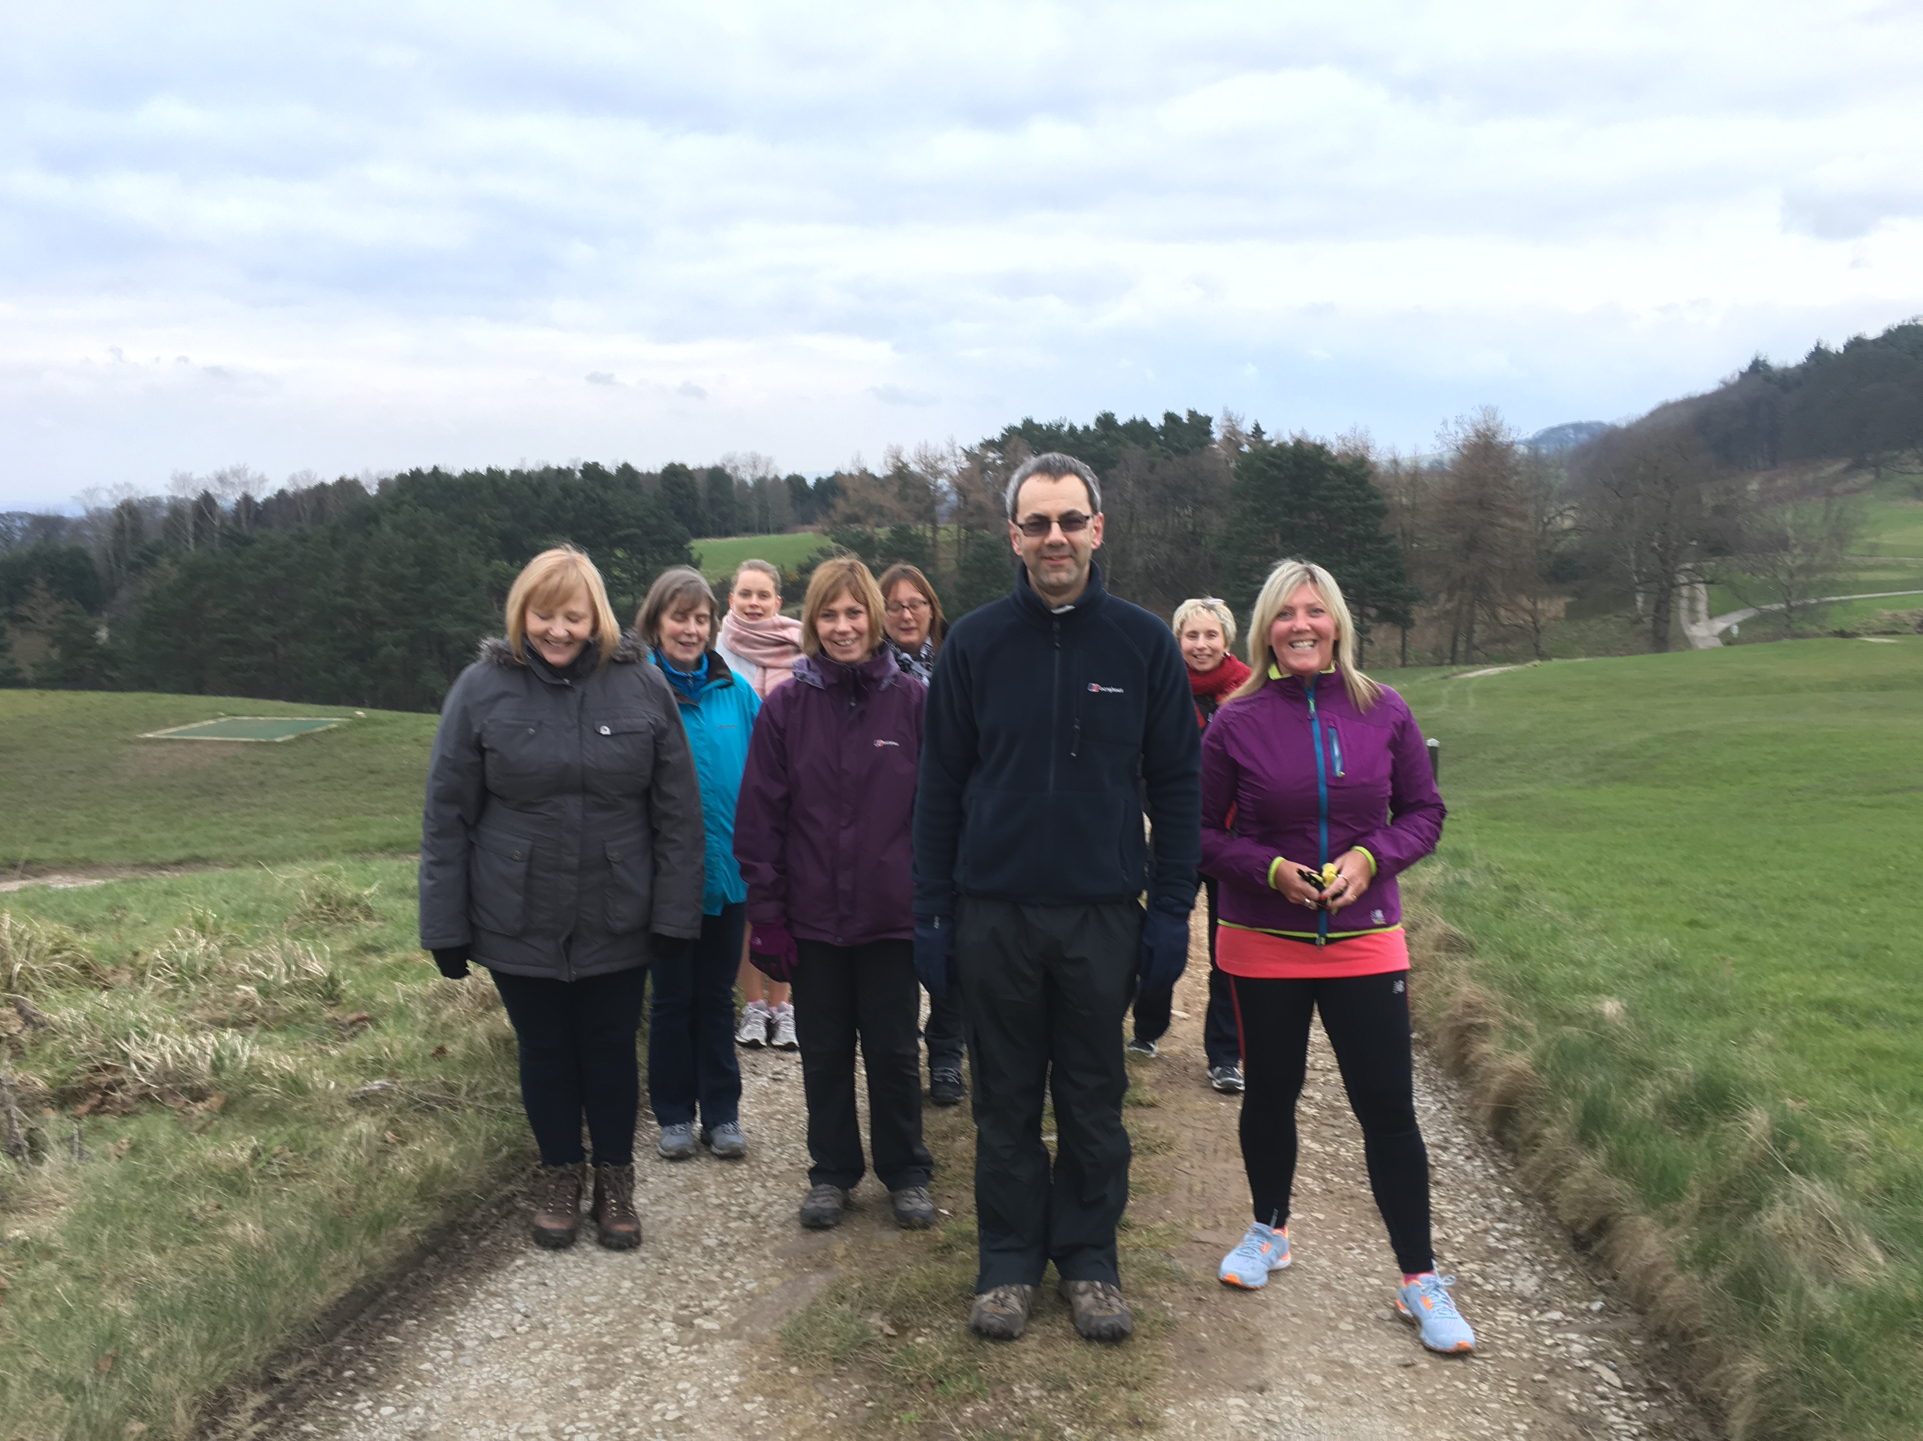

On Saturday afternoon there were several team bonding sessions and I enjoyed a lovely and refreshing walk around Shrigley Hall grounds before heading back to get ready for the gala dinner, sponsored by John Barker.

Once again we were up bright and early again on the Sunday morning for two excellent sessions before the event finished. First up was John Hotowka – part motivational speaker, part magician. John’s interactive presentation was brilliant and really got everyone involved – some much more

than others – but I won’t say too much as John might be one of the speakers at our regional conference in November. The session ended with a presentation by Amit Patel from Grant Thornton who had a hard act to follow with his session on risk management, but he needn’t have worried as it was excellent. The event is really popular, so much so I know some delegates paid for themselves to attend. Copies of the slides of this and other Audit, Risk & Governance events, can be found on the web at http://www.cipfa.org/members/regions/north-west/audit-risk-and-governance-group/past-event-downloads

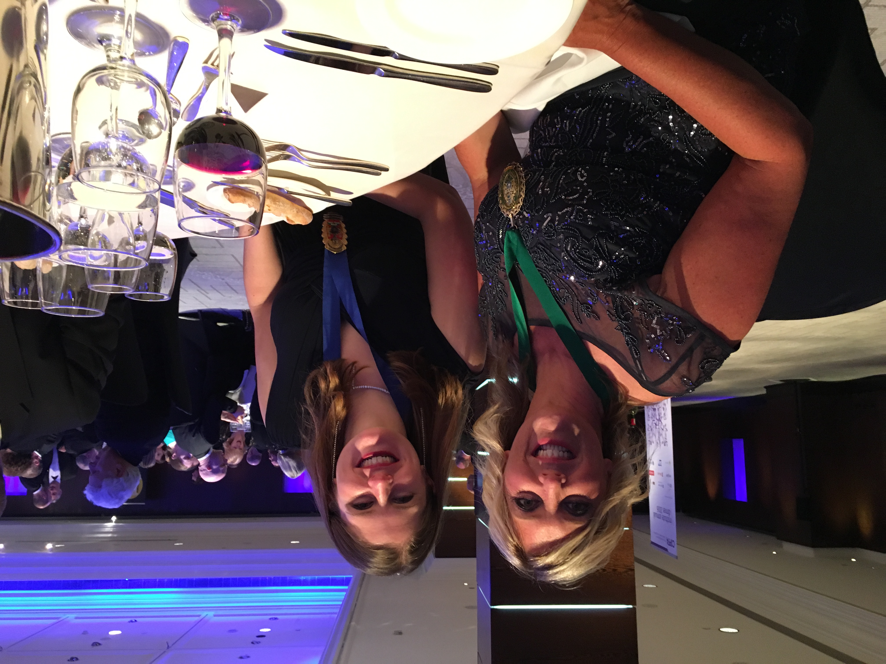

As regional President, I was delighted to be invited to the

Institute dinner in London. It was a really stylish event

with the keynote speaker Isabel Hardman, political reporter

from The Spectator. It was an excellent opportunity to

meet like-minded colleagues and award winners from the

public sector, including esteemed past National President’s

and even the representative from PIPFA, Pakistan’s

equivalent public sector body. I was also able to catch

up with colleagues from the North West and other

regions. It’s difficult to make time to see colleagues nowadays so these evens provide the space to keep up to date with what’s going on. I was very pleased to be seated by Kathryn Long, Vice President of the National Students Network who if I can remember is the Accountant for the London Bridges Trust (sorry Kathryn if this is wrong!) but we had a really interesting conversation about her day job! I’ll look forward to catching up with Kathryn at the National Conference in July when she takes over from Katie Goodall as Student President.

We have our regional AGM soon – in March so I’ve been busy preparing for my Presidential speech. It’s difficult because as a region I feel we’ve achieved so much since I took up my position as President and I have been blown away by the helps and support of the regional volunteers. I’m going to have to try and keep to 10 minutes otherwise there’ll be no time for the other speakers! The AGM is being held at the Pyramid Theatre in Warrington on 18 March. Its free event starting with lunch and after the AGM we have two speakers – Philip Lloyd-Williams who will talk about political intelligence and CIPFA President John Matheson. If you would like to book a place please email cipfanwnw@cipfa.com

**And finally…..**

Tough Mudder training update – our TM team have met up and had our first training session. This mainly consisted of us climbing around on children’s playground furniture for a bit, wondering what to do next and running up some stone steps while being photographed by an 8 year old in very unflattering positions. Going well then eh….

As I was on holiday for just over 2 weeks during February, I didn’t do that much this month, except swim, sunbath and drink cocktails of course ☺ and if you are a beach lover then I would highly recommend Koh Phi Phi in Thailand, it was very difficult to muster up the motivation to get on the ferry to come back home. And just to annoy everyone who is fond of holidays even more, here are a couple of snaps of me doing what I do best in Thailand!

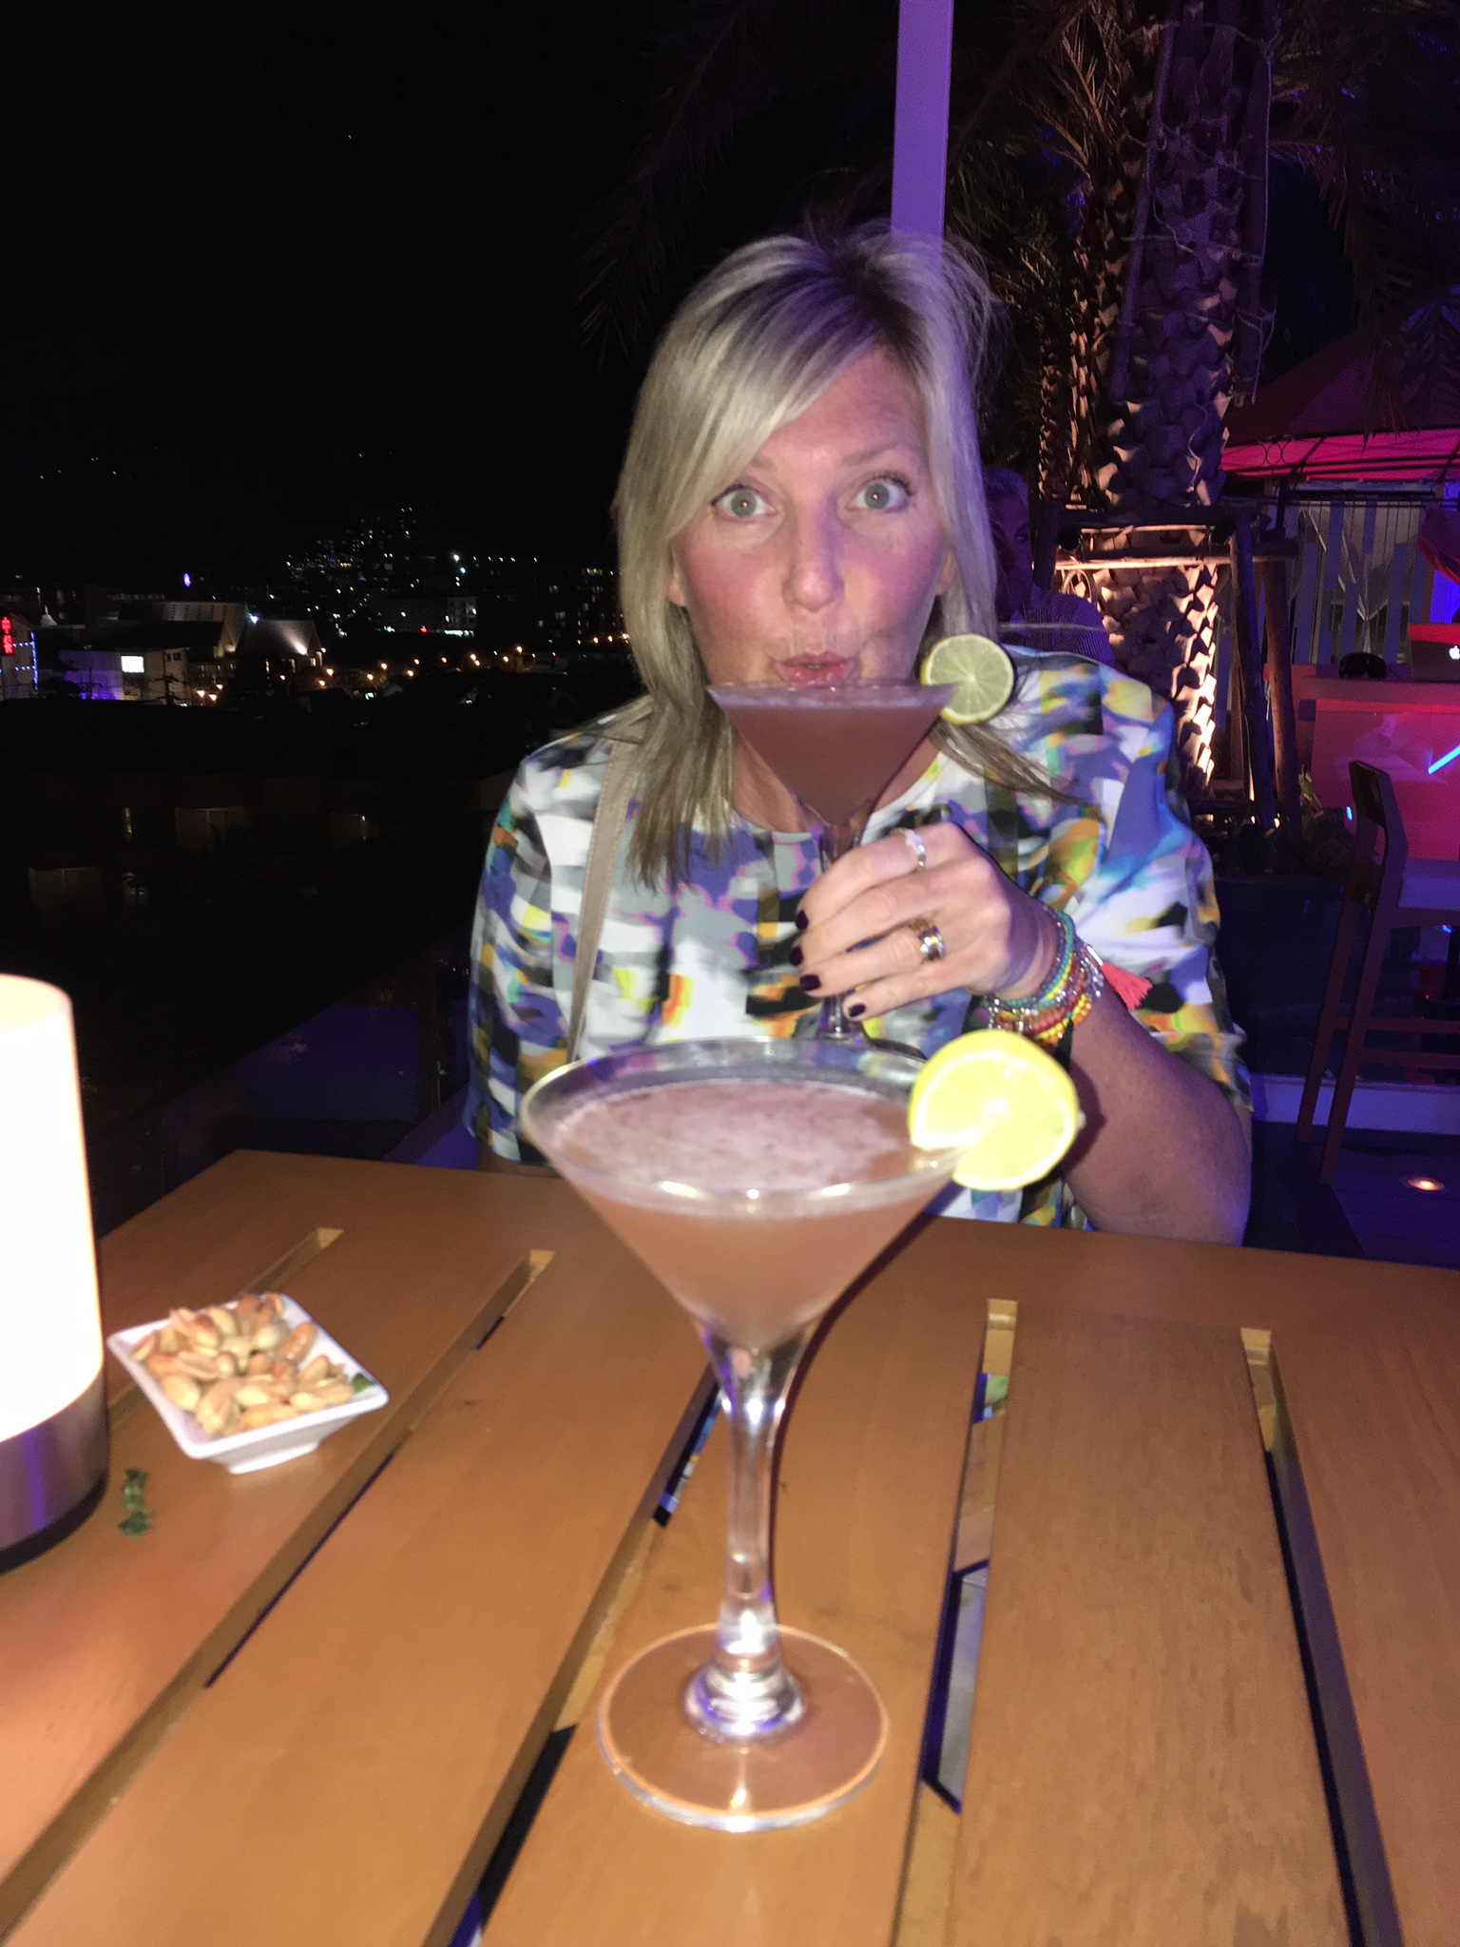

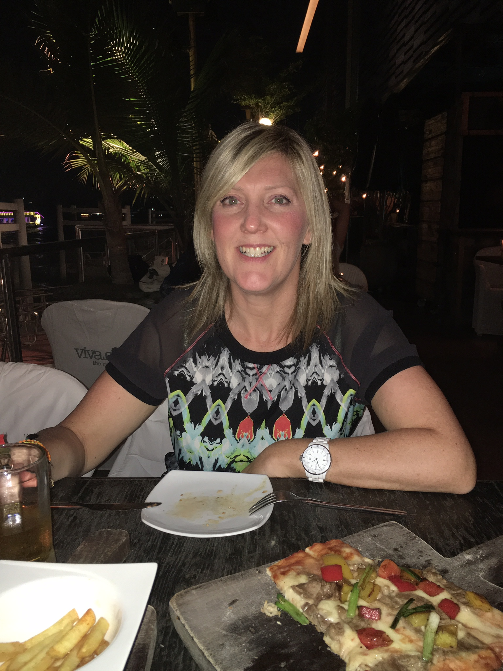

Shaer

**Twitter –** search [twitter.com/CIPFANW](https://twitter.com/CIPFANW)

**LinkedIn –** search for the Group CIPFA North West

**Facebook –** search for the Group CIPFA North West