CIPFA North West Society



**Presidents Blog – August 2015**

Well I guess that’s summer over and done with then, and what a lovely one sit was too. I was so glad to see Christmas cards and gifts appearing in the shops this month…...not!

**Exam Successes**

Fantastic congratulations to all students passing their exams this month, considering the other things going on in your lives let alone holding full time jobs it’s a major success to get through exams now. For those who didn’t quite make it as planned, stick with it as you’ll get there – I am speaking from experience so I know what it’s like. If you feel you need any support or help on anything in particular, get in touch with our Student Network as they will be able to help or point you in the right direction. They might even be able to run a specific event if there are a few of you struggling with one specific topic. You can contact them at [NorthWestStudent@cipfa.org](mailto:NorthWestStudent@cipfa.org)

**Event Planning**

The main activity for CIPFA North West this month has been in organising our autumn events. Whereas in general it seems to be quieter in the summer, it’s quite busy for us in getting organised to ensure we have a worthwhile programme that will be of benefit to our members and students.

**On 11 September** the Southern Section are holding their half day event in the Liver Building in Liverpool which is a magnificent venue. I’m very much looking forward to attending that.

**On 18 September** the Northern Section are holding their full day event at the Castle Green Hotel in Kendal. They have an excellent line up of speakers and the only reason I’m unable to attend is because I’m double booked

**On 9 October**, the Audit, Risk and Governance Group have their full day Conference at the new prestigious KPMG offices in Manchester. The event features a session from Rachel Tiffin, the Head of CIPFA’s new Counter Fraud Centre initiative

**13 November** is the regions flagship event, the Annual Regional Conference and Society Dinner and awards ceremony. This full day event takes quite a lot of organisation and planning as we generally have 7 or 8 speakers on the bill. This year we also have a student breakout session. The Annual Dinner in the evening is all about celebrating our successes as a region during the past 12 months. New members are invited to have their certificates formally presented and we also give out a volunteer of the year award. This goes to someone who had made a specific contribution to the region during the year as we recognise that with full time jobs, families and other responsibilities it’s a huge ask for someone to then give up their time to support the members and students of the region. We’ll be discussing the nominations at our Council meeting next month and deciding on the winner

Planning unfeasibly ahead, our AGM next year is set for **18 March 2016**. Unfortunately our National CIPFA President, John Matheson was unable to attend any of our events this year due to prior commitments on our planned dates. So I’ve made sure he’s available to come and talk at next year’s AGM. He’s looking forward to coming up to the North West as he was quite disappointed that he wasn’t able to make it this year. I don’t have a venue as yet but I’m hoping for something a bit special. Well, I guess I would, wouldn’t I?

**Supporting CIPFA**

As a region we’ve also been busy supporting CIPFA nationally and have been involved in arranging a workshop and training with our health colleagues in the North West to help both health and local government understand the differences in our respective financial management. That will hopefully be arranged for the autumn. And on the same subject, we have supported CIPFA and Future Focussed Finance to run an event on 12 October in Liverpool that considers both the blockers and barriers to health and social care integration. Look out for further details of these on the main CIPFA events pages

A couple of our Council members have also been drafting articles for CIPFA Thinks and CIPFA Voices. David Taylor-Smith is drafting an article on post-election Housing and Mike Thomas’ article on Devolution will be out early in September. Keep an eye out on the website for these at <http://www.cipfa.org/cipfa-thinks>.

And finally, because I generally have absolutely nothing to do (!) I climbed Helvellyn in the Lake District in last month. I was a bit concerned as some friends I went with had previously done the national 3 Peaks in 27 hours so I wasn’t sure I’d be able to keep up but I was really pleased that I did. We didn’t attempt the ‘striding edge’ though which is so narrow on the top that two people can’t pass, I’m far too clumsy for that!

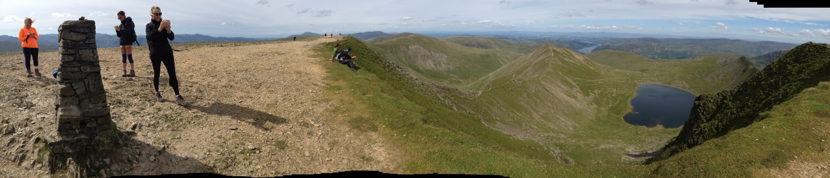

**Fantastic views from the top of Helvellyn with my fellow walkers**

I also had a lovely week away in Marbella whereby much Cava and Tapas were consumed. I’m doing a sprint triathlon next month so vowed to keep up my training during my holiday and I did actually venture into the sea for a long swim at one point. 5 minutes later after I felt some seaweed on my leg, had swallowed some sea water and had actually gone backwards, I got out and decided that a week off training would be good for me to rest ☺

I’ll let you know whether that paid off or not next month!

Shaer

**Twitter –** search [twitter.com/CIPFANW](https://twitter.com/CIPFANW)

**LinkedIn –** search for the Group CIPFA North West

**Facebook –** search for the Group CIPFA North West