CIPFA North West Society



**Presidents Blog – May 2015**

Well it’s been a busy old month since I became President but a really exciting one too. As President of the North West I am invited to join CIPFA’s Board for the Regions, where all the regional representatives and regional President’s get together once a quarter to discuss the reciprocal support and developments between the Institute and the regional committees. I knew quite a few of the people there as I have been involved with CIPFA for quite some time so it was great to catch up with colleagues and friends. And of course to catch up with our own North West Regional Representative, Lee Helms. I really felt as though I was able to represent and contribute to the support of the members and students of the North West as there were some really interesting discussions about how CIPFA is moving forward and the regions role in that.

The meeting was held in CIPFA’s new offices in Mansell Street, they’re really contemporary and a great office space and there is a Members Lounge for CIPFA Members to use to catch up, watch a bit of news and just grab a drink while doing some work. I spotted the new CIPFA stand on the way out and in fine form, couldn’t resist a photograph with it.

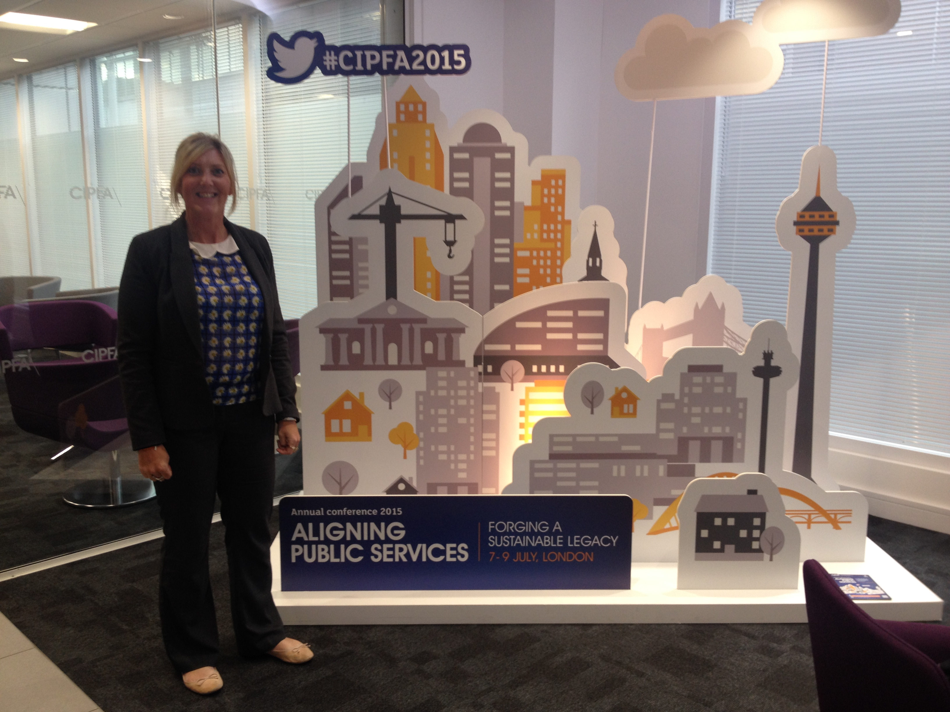

It will be making its appearance at CIPFA Conference in July. You can follow what’s happening and all the latest news on the CIPFA Conference on Twitter at #CIPFA 2015. I expect that there will be another photo in July’s blog in exactly the same position

Last month I reported that it was on my wish list to start up a retired members group and I’m really pleased to say that we already have a Chair and Secretary! Retired Members David Johnston and Sheila Don are taking on the respective roles and are keen to get going. If you are a retired member and would be like to be involved either in the event organisation or attending events, let me know and I’ll pass your information on. We’re hoping to build up a network of retired members who can mentor students and also put on some informative events and social gatherings.

I was really pleased to be invited to a celebratory lunch hosted by the North West Group of the Chartered Institute of Taxation (CIOT) and the Association of Taxation Technicians (ATT) this month at the Great John Street Hotel in Manchester. It was a great event where the national CIOT and ATT Presidents were in attendance. I was able to make some excellent new contacts with several people that would be able to support us at CIPFA North West. I already have the feelers out for a motivational speaker at our regional conference on 13 November and a speaker for the Retired Members group from an organisation called Tax Help for Older People. I also learnt quite a lot about income and corporation tax and heard some great stories. Both the CIOT and ATT are keen to get more involved with other professional bodies across the North West and as a result we might get together to look at hosting a joint event in the future.

I am also very pleased at being asked to speak at the North West CIPFA Student Network (CSN) at their event in Manchester on 3 July. It’s their inaugural event since being re-established and there looks to be a promising turnout. There is a social event later on after the event finishes which unfortunately I can’t make but I’m sure there will be a photo or two posted on our social media sites. If you would like to book on, follow this link: <http://www.cipfa.org/training/c/cipfa-in-the-north-west-student-network-summer-event-2015-20150703-north-west>

I had a visit from a CIPFA colleague past last week – Chris Tidswell from CIPFA in Wales. Chris has a new role within CIPFA as Head of Corporate Partnerships. Chris came to see me to talk about the sponsorship we generate as a region to contribute to keeping the cost of our events down for delegates. We also chatted about the Southern Section event on 11 September as Chris might be able to help us source a speaker from a Health and Social Care Integration in Wales perspective. Wales are much further ahead on integration than England so we could learn a lot from them and save reinvesting the wheel. We are trying to attract more health delegates to our events for networking opportunities and building contacts on the integration agenda so that we don't have to start from scratch. It’s great to see the Institute supporting the regions in this way so we’re not on our own.

Now, I’m not sure if anyone saw this but something in CIPFA’s national Twitter page got me very excited earlier in the month. I am very pleased to say that I do have quite a bit of CIPFA merchandise – cups, beakers, coasters, bags, pens, pads and probably lots more things that I’ve picked up from events. But what about these bad boys:

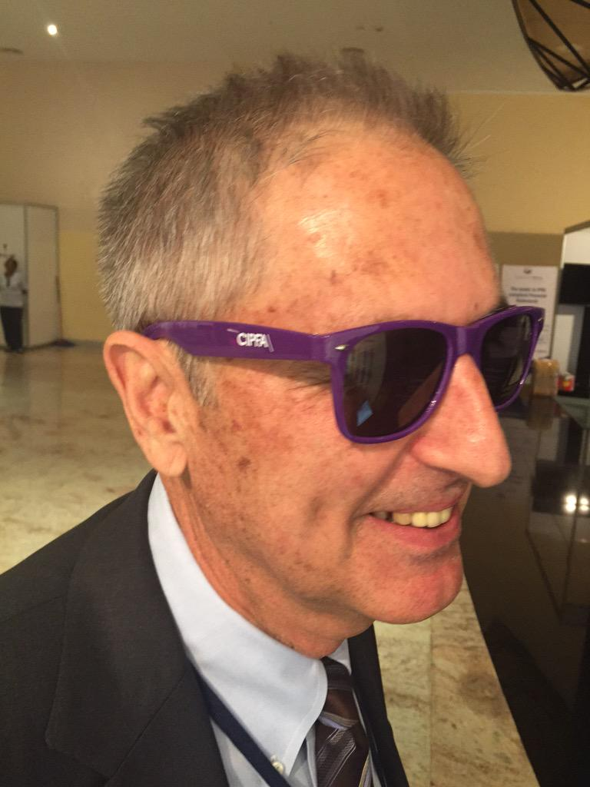

CIPFA Sunglasses! This is Ian Ball sporting the fine pair on a break

from speaking at the Africa Congress of Accountants event.

I hope they are giving these out at the National Conference in

July as I’m definitely after a pair (or two). I’ll be on the regions

stand at the Conference at some point for a short time – each region

is taking its turn – so if you’re going, pop along to see us.

Well that’s all from me for May 2015. You might remember that in April’s blog I mentioned that after the success of my Grand National winnings (£10) I was going to chance my luck at Chester Races. Well I gave it a go for two days – one being a total washout – and didn’t fare much better in the winnings than the National but they were good days out anyway! I hope you all have a lovely Bank Holiday. I’ll by cycling 100km through London through the night to raise money for three Women’s cancer charities. I’m a bit nervous as I’ve only got up to 20 miles in practice so far. I have no idea why I do these things!

Shaer

**Twitter –** search [twitter.com/CIPFANW](https://twitter.com/CIPFANW)

**LinkedIn –** search for the Group CIPFA North West

**Facebook –** search for the Group CIPFA North West