CIPFA CIPFA North West Society





**Presidents Blog – October 2015**

Hello everyone and welcome to autumn! After a lovely long summer it’s been all hands on deck again this month attending and organising events and supporting members and students in the North West.

On 8 October I was invited alongside CIPFA North West Regional Representative, Lee Yale-Helms to attend the **North West NHD Finance Director’s Contact Dinner**, being held in Carden Park in Cheshire. Myself and Lee were there in our capacity as CIPFA Ambassadors and it was great to meet up with NHS colleagues from the North West, especially as we have made so much progress in strengthening our links with the NHS. I was also quite fortunate to bump into a few people I knew alongside making new contacts.

As CIPFA and the NHS continue to build good links it was a great opportunity to talk to health colleagues about how they are taking their trainees and graduates forward to professional qualification. I had a brief chat with Nigel Gloudon from NHS England about their talent management scheme and we have agreed to get together again to talk about it further as it sounds like there is a lot of best practice that we could tap into.

On 14 October I attended the **Liverpool University Business, Finance and Law Fair** and gave a presentation on finance in the public sector to the students. I then spent the rest of the day on the CIPFA stand with Carly and Cody Wilson, CIPFA sisters! It was really busy and there was a lot of interest in the CIPFA graduate recruitment scheme which is proving very successful across a variety of organisations.

At the **Conference for the Regions** this year – a conference for regional volunteers – I was overwhelmed that Ian Coleman won the Hedley Marshall Award for regional volunteering. Ian has been involved with CIPFA since 1985 and has held a host of roles, giving up a significant amount of his personal time to support members and students in the North West. I have known Ian for a long time and have

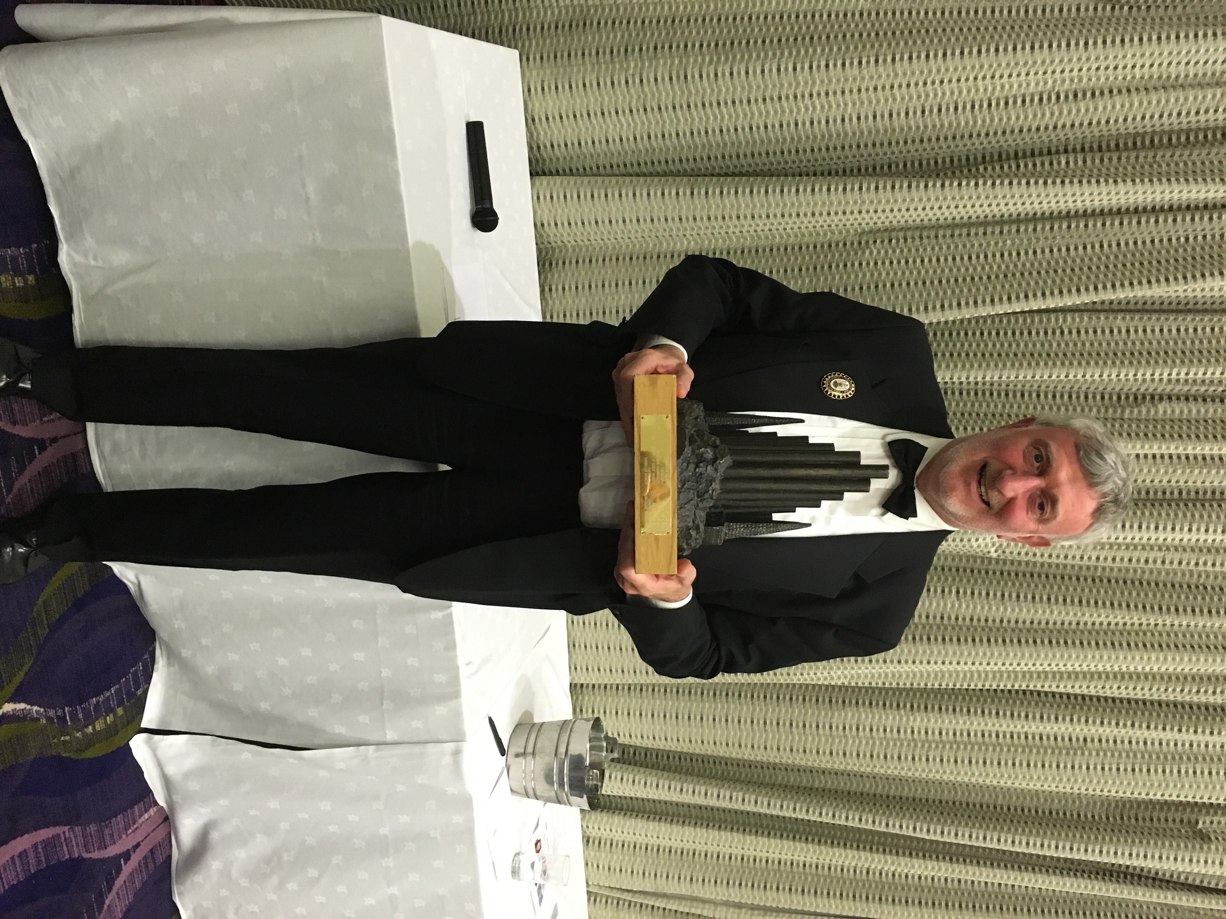

always looked up to him as he has vast knowledge and

experience of all things public sector. So many congratulations to him for a very well deserved award.

At the conference the arrangements for the future of the regions meetings were discussed following the change to the constitution for elected CIPFA Council Members. You may be aware that at present Council members are elected by sector and that this will change from 2017 as members will be elected by region. This should provide extra opportunities for regions to shape the way CIPFA is going forward and provide a much closer link between CIPFA HQ and regions.

On 21 October I attended the CIPFA Health Conference held at Grant Thornton’s offices in Manchester, chaired by Richard Harbord. It was a packed out event and there were excellent speakers on the health and social care integration agenda. What started off a bit doom and gloom eventually gave us much food for thought, ending on the progress made in Manchester with their devolution agenda which all sounds very exciting. Although they do have significant challenges ahead, despite receiving £6b devolved funding for health and social care, there is still a predicted £2b gap as they approach 2020.

**Regional Conference and Dinner**

I’m really looking forward to our Annual Conference and Dinner on 13 November. All the arrangements have been made and all there is to do now is turn up! I am going to let the cat out of the bag on something though as I am bursting with excitement. At the dinner I will be presenting certificates to new members and celebrating regional successes during the year.

We have our usual Volunteer of the Year award that we have renamed the William Jolliffe award as a tribute to past National and Regional President Bill Jolliffe who sadly passed away during the year. I’m very pleased to announce that this award is to be presented to Simon Rafaelli, former Chair of the Northern Section and now a Council Member. Simon revived the Northern Section from a defunct group to the very successful group that it is today.

We have a new Lifetime Achievement award this year that we have named the Barbara Kay Award in recognition of Barbara becoming the North West’s first female President. I worked under Barbara around 15 years ago and she encouraged me to take CIPFA and aspire to be a CFO. The winner of this award is Eric Cadman, from the Audit, Risk and Governance Group. Eric has worked tirelessly for the region for many years and is very well deserving of this inaugural award.

**And finally**…..well it’s been a month of rugby and football. I’ve really got into the spirit of supporting both England and Wales (as I am CIPFA North West but am actually Welsh!) and had a fantastic trip to see Wales v Uruguay in Cardiff at the Millennium Stadium and then again at the Wales v South Africa quarter final at Twickenham. It was a shame neither Wales nor England could finish to victory but I had a great time regardless.

For those keeping up with my outdoor pursuits and half-hearted exercise plans, I have been a bit lazy this month having only embarked on a bit of running. However you’ll be pleased to note that I have decided to walk Hadrian’s Wall in the summer, just for fun of course. And my sister has persuaded me to climb Ben Nevis. So out the old trainers and boots come to start a bit of training for next year.

On the fun side, I did have a lovely night in Anglesey with my girlfriends for a 40th birthday. It was fancy dress so I went as……Rambo. Don’t ask ☺

Shaer

**Twitter –** search [twitter.com/CIPFANW](https://twitter.com/CIPFANW)

**LinkedIn –** search for the Group CIPFA North West

**Facebook –** search for the Group CIPFA North West