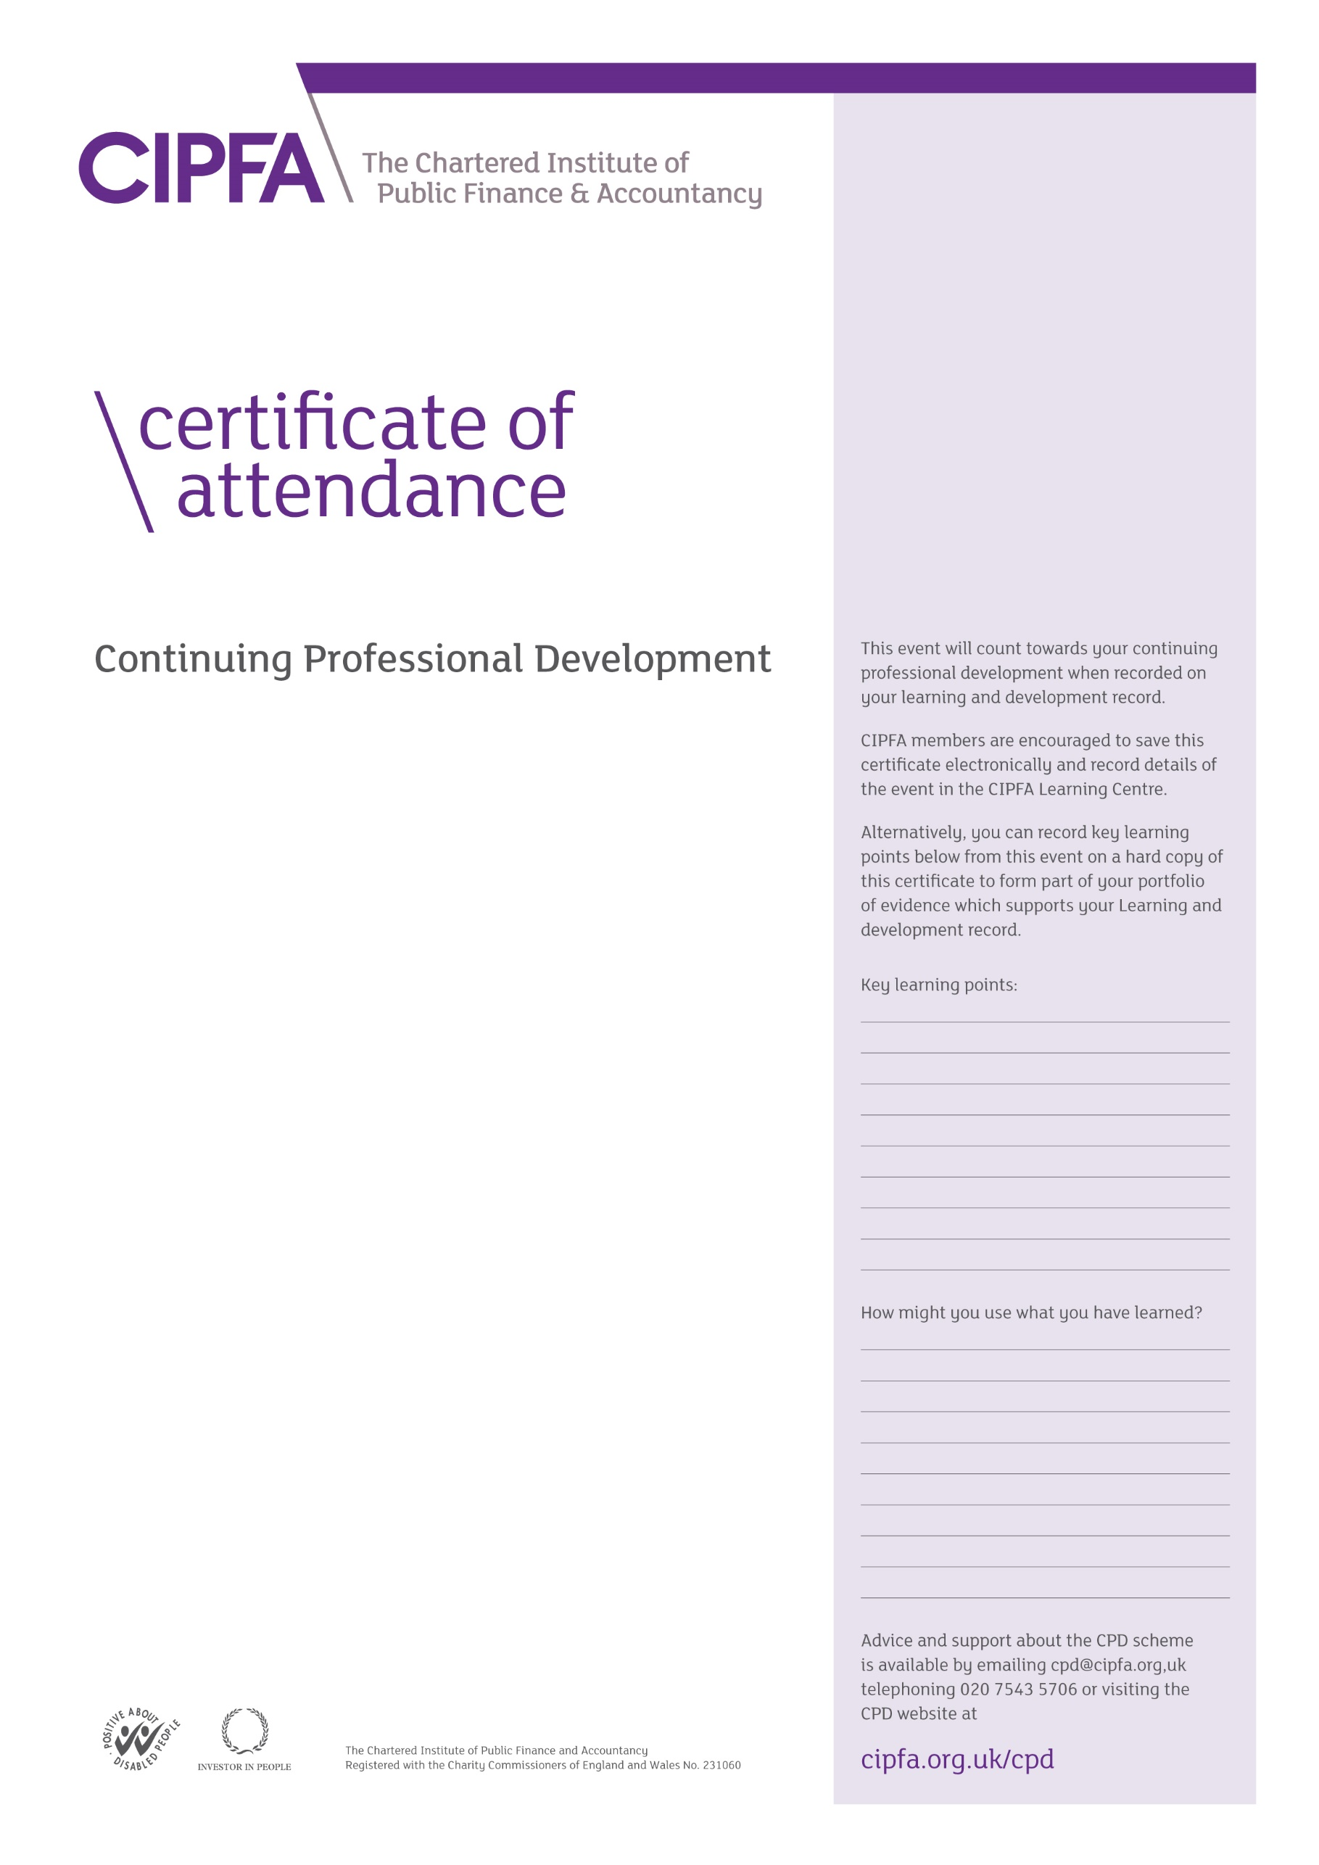

CIPFA South East Region Digital CPD

29 January 2021

Financial Resilience and addressing future risks

5 February 2021

Financial Resilience in Local Government

Presentations by

Ben Zaranko, Alix Bedford, Roy Nolan, Andrew Hinds, David Ellis and Paul Dossett

It is for the individual to determine the relevance and amount of time that this event counts towards their CPD

This certificate will be validated by reference to the delegate attendance list maintained by CIPFA for this event.