What’s on in CIPFA South West
– December 2017
To all our CIPFA South West members, students and all the colleagues who support us!
I don’t know about you, but it starting to feel like Christmas at home and at work now. Christina attended a reception at the House of Commons, and here is the photo she took on the way in after going through security. Even though the outside looks unattractive, now scaffolding is up, the inside is amazing, and there were loads of people about. She was there representing the Institute for Apprenticeships at an award ceremony for the International Association of Bookkeepers and international Association of Accounting Professionals. She had not come cross them before, so was curious, and it was nice to find how other associations take pride in their qualifications and the hard work people put in to achieve them and uphold high standards. People she met there including Graham Hambly from PQ magazine, which is well worth a read if you are a student or line manage a student, and reps from the Chartered Institute of Payroll Professionals (CIPP). She said “I always find Payroll an interesting area, and we discussed whether they would be better supporting Finance colleagues as well as HR, who they tend towards. Considering the risks that payroll has, and without being too disrespectful, I know who I would prefer in my corner!”
Xmas Tree in Westminster Hall
Inside the House of Commons
We are very interested in hearing from you when you get the opportunity to go to different occasions like this in your capacity as an accountant or in representing your organisation. It gives a real flavour of the influence we have and opportunities to represent our Institute, and the public sector. Contact us and let us know and we will put it in the newsletter.

Working together with HFMA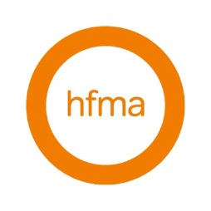
John Bloomer and Esther Giles represented our Regional Council in a conversation last month with Neil Kemsley, who is Chair of South West branch of HFMA. We are delighted to have been invited to their next Branch meeting in March, and we hope to organise reciprocal arrangements for meetings in the future. Watch the website or our newsletter for more details in the months to come.

CIPFA Central Government Seminar 23 November at the Institute for Government
As some of you know, Christina works in Central Government. After missing last year, CIPFA hosted the previously held annual event focussing on providing a free event for our members who work in central government. The event had the privilege of both Meg Hillier from the Public Accounts Committee and Sir Amyas Morse, Comptroller and Auditor General for the National Audit Office as well as other notable colleagues. She is happy to share slides if any of you are interested in what was covered.
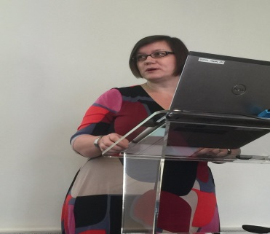 Meg Hillier, Chair, PAC
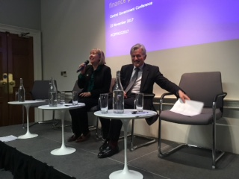Gillian Fawcett, CIPFA and Amyas Morse, C& AG, NAO
We would like to know if you have attended any CIPFA sector specific events –such as Health or Local Government, and share via these pages updates. It should not take too long to give us some highlights. Contact us to let us know of any such events in our area and any comments you have.

CIPFA Ethics Round Table 30 November, CIPFA HQ
Christina was very delighted to have been part of the organising of the Ethics Round Table event, held on 30 November. She has told us before about her membership of the CIPFA Ethics Working Group, chaired by one of our Past President’s Margaret Pratt, in her November blog. The event was successfully achieved, with the support of CIPFA’s Keeley Lund and Alison Scott, and ably chaired by Carolyn Williamson, CIPFA’s Junior VP. There was had around 30 colleagues and a great representation from other CIPFA Regions (as well as our own through Christina) who the Ethics WG hope will host Ethics sessions at AGMs and seminars in the next year, to help us get the debate going about the moral courage it takes to do our jobs, whatever our roles or grades, whether we are newly qualifieds in the workplace or Finance Directors. Talking Truth unto Power never gets easier, and our members are being called on to make judgements more than ever in increasingly complex situations we face. Christina hopes to have the topic debated in her Presidential year, and welcome stories from all of you, so we can share experiences and prepare ourselves, and our up and coming students. She said it was a brilliant event.
If you need any material to host any event in your workplace, Christina is very happy to support you. Contact us to request any help.

And don’t forget that the Annual CIPFA Conference is coming to the South West – July 2018
Set the date: 11-12 July 2018!
CIPFA SW will be looking to see how we can support the event and get our members and students attending. A great time to get involved with us!!!

CIPFA SW Committee Regional Plan
CIPFA SW has now resubmitted our plan for 2018 to CIPFA. We have now increased our bid to secure improved resources to the Committee from our admin support, Jo, and for funding to secure venues to host events. The priorities remain the same as I reported before, to:
- Revitalising our CSW northern hub;
- Communication with Member through our website, monthly newsletter and blogs by CSW Council members;
- Firming up links with other Accountancy bodies in the South West for joint events or mutual/reciprocal attendance arrangements
We could do SO MUCH MORE with more volunteers to arrange or host events!!!
We have vacancies on our Committee, and we would very much welcome approaches from members such as Finance Directors or S151 Officers to offer to host events, so that we can have more local events, that are easier to get to after work or for breakfast meetings. We recognise CSW members and students are a long way from events hosted in London, Birmingham or Manchester so we would be very happy to help in getting more activity in our area.
We would particularly welcome recently qualified members, who would like to influence how we can support our members in this beautiful South West part of the country, and who potentially would like to consider the opportunity to stand for Council and get some real strategic experience. Use this link to get in touch.
Previous Regional Plans can be found on our website

Have you a venue so we can Host local events?
Can you host an event in the Bristol, Bath, South Gloucestershire or Swindon areas? We have a range of speakers very happy to come to us on a range of topical events. But we are missing hosts and some help in making it happen. We particularly want to have an event that covers the huge subject of Ethics and ethical behaviour, and the challenges we face as finance professionals in the workplace –at whatever position you are. You may like some other topics covered as well, so let us know – especially if you want to cover the topics yourself as a speaker.
Contact Christina via our website or respond to the email you should have received on 26th July, when she emailed many of you directly.

CIPFA South West gets social!
Have you joined us on LinkedIn, Facebook and Twitter yet? Please do, and find a way that we at CSW can keep you up to date with upcoming events, news and discussions that may be of interest to you as a CIPFA member. If you have any ideas on content or suggestions on groups we as a Region should be following then please get in touch.
CIPFA SW Students can also join the student group on Facebook to discuss student related matters such as exams, revisions and events.

Have you read Spreadsheet yet?
Do you know any of us can write articles in Spreadsheet magazine. Christina managed to get 3 in the edition just released. Here is the Spreadsheet link. She put in a piece about AAT and CIPFA working together, on page 26, although it is under the student news heading for some reason, a piece about CPD through Regional activity on page 24, and in publicising work on the Technical Panels – AASP – on page 17 under volunteer activity that she commented on in the September newsletter.

CIPFA Council Meeting – next one 14 December, 2017
Our council representation John Bloomer will no doubt provide us with an update of the next CIPFA Council meeting. John will be happy to provide headline details from that meeting in the next edition, and Christina will add her comments from the meeting in her blog. She is looking forward to the night before, as the Council will be meeting up with Past Presidents, celebrating all those previous Presidents, and well-known names. In particular, you get to hear what they do after being President, and how so many of them continue to support CIPFA activities. Christina has been very lucky to be working with Margaret Pratt, our first lady CIPFA President, on taking forward the discussing about Ethics. Here is a picture of them from last year outside the room dedicated to Margaret.
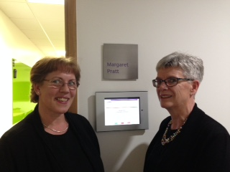

CSW needs your help! There are some simple things included below that you can do to support CSW as your local Region, including:
- Support CSW Regional Council be more representative – so we need more volunteers to sit on council and support us in supporting you!
- Help us communicate better with you, so if you are on LinkedIn, Facebook or Twitter – join our Groups, share your thoughts and tell us how we can support you more on networking, CPD, even just finding out what CIPFA is doing.
- Consider being our newsletter editor. If you consider yourself a wordsmith and have a few hours to spare why not help us improve this newsletter? Contact us to find out more.
- Help us in developing our area hubs in the south and north of our regions, based loosely around the Plymouth and Bristol/Bath/Swindon areas. Look out for more information in our next newsletter.
Please message us on Facebook or email Joanna Hall if you are interested or if you would like more information and a chat.

Shout out for Student representatives!
Representing the students - over 100 at last count - in our region offers valuable experience to improve your CV and extend your networking across the country. As a student representative you could be involved with a range of activities, including:
- Sharing your views on courses or topics that are covered at events in your region
- Presenting student issues to the CSW council
- Discussing ways of improving the student experience and support
- Organising student CPD and social events
If you're interested in being a student representative and you want to find out more about the role, please message us on Facebook or email Joanna Hall.

Save the date! 2018 events for your diaries:
CIPFA SW AGM and Conference
16 March 2018, Torbay, venue TBC. Some great speakers have been confirmed including the National President Andrew Burns, the CIPFA Chief Executive Rob Whiteman and the Chief Executive of Cornwall CC, Kate Kennally.
ERC, Torquay
CIPFA SW Annual Regional Dinner
18 May 2018, SS Great Britain, Bristol
CIPFA Annual Conference
11-12 July 2018, Bournemouth

Full details of these events and bookings will be available in future SW newsletters and on the South West regional page.

